Hebrews 6
“The Anchor of our Soul”

Scripture: Hebrews 6:1-20

Memory Verse: “This hope we have as an anchor of the soul…” Hebrews 6:19a

Lesson Focus: We have hope because Jesus is the “anchor of our soul.”

Activities and Crafts: Coloring picture, Work sheet
1st & 2nd Grade: Craft: Anchor of my Soul necklace.

Introduction: Show the kids the pictures of anchors at the end of the lesson. Talk about what anchors are used for. Talk about how big some of them have to be to secure the ship. Tell them that our Bible lesson today will focus on our anchor.

Bible Study:

Hebrews 6:1-3
√ What is the “therefore” there for?
In Hebrews 5:12-14, the writer of Hebrews has just told us that we are to grow
up by eating the solid food of the Scriptures. The Bible feeds us spiritually. As we read and listen and change according to what we study in the Bible we grow up in Christ. So we can learn and grow and go beyond the basics of our faith. We can feed on the “meat” of the word. Verse 14 tells us that as we practice and use the Word of God we teach our senses to know “good and evil.”

So since we are to grow up and feed on the word of God then we leave the “elementary” things of Christ.

√ How many of you are in Elementary school? What if you stayed in elementary school forever? What if you never graduated to Junior or Senior High school and never went to college. Do you think you would be prepared to be a grown-up and to make a living in a job?

When we first come to know Jesus as our Savior we know a few elementary things:
- Repentance from dead works to faith in God.
- Jesus is God
- Jesus died on the cross to pay the price for my sins.
- Jesus was resurrected
- I need to believe in Jesus and know that He paid the price for my sins. I need to repent of my sins and confess Jesus as my Lord and Savior.
- Repentance means to turn from our old way of life and to turn towards God’s way of life.
- Baptisms and Laying on of hands:
- Not the normal way we see baptism. This baptism involves the Holy Spirit.
- Baptism of the Spirit it to be filled with the Holy Spirit
- Laying on of hands is used to send someone forth on a mission for God and to bless their ministry and fill them with the Holy Spirit
- Resurrection from the dead:
- Jesus died and rose again. John 11:25
- Jesus sits at the right hand of God
- We will rise from the dead in new life with Jesus in Heaven
- Eternal Judgment: That God will judge everyone.
“in the day when God will judge the secrets of men by Jesus Christ, according to my Gospel.” Romans 2:16
2 Corinthians 5:10

√ What else do you know right after you accept Jesus as your Savior?
Not much – but that is ok. When you are a baby you learn to crawl before you learn to walk. And as a baby-Christian you first trust in Jesus and then you learn more about who God is by reading and studying the Bible and having a relationship with Jesus through prayer.

√ What are we to do according to Hebrews 6:1 after we leave the “elementary”
principles of Christ? (We are to go on to perfection.) What is our
perfection? (To be like Jesus)
Ephesians 4:13; “…till we all come to the unity of the faith and of the knowledge of the Son of God, to a perfect man, to the measure of the stature of the fullness of Christ.”

Colossians 1:28: “Him we preach, warning every man and teaching every man in all wisdom, that we may present every man perfect in Christ Jesus.”

Our goal is to be like Jesus. We are made perfect only in Heaven – but we are to grow spiritually and become more like Jesus every day. We don’t need to measure ourselves by how smart we are or by how good we are at sports. We are to measure ourselves by how much we are like Jesus. This is the only measurement that we should really care about.

√ Do you ever ask yourself this question, “am I more like Jesus today?” What am I doing to be more like Jesus?

√ What does the word “doctrine” mean? (What we believe in)
√ What do we believe in?
- Jesus died for our sins
- Jesus was resurrected on the third day
- Jesus is the only way to God
- I believe in Jesus as my Savior
- Baptism: To publicly announce to everyone that I believe and want to follow Jesus.

Hebrews 6:3: Says that they will leave the teaching of elementary things in the
faith to move on to deeper spiritual things if God permits. This is a warning call from the Bible to make progress in our faith. We should always be growing…always moving forward with the help of the Holy Spirit.

Hebrews 6:4-8
These are some of the scariest verses in the Bible. We need to understand that
God tells us in John 10:27-28 that “nothing can take us out of God’s hand.” A true believer in Jesus Christ can know that He will be in Heaven someday. But someone who says they believe, but never show evidence of the Spirit working in his or her life, probably never truly believed in the first place. Jesus taught us the parable of the seed that fell on good soil and bad soil to emphasize the point that some may say they believe but they never grow. (Matthew 13:23)

Hebrews 6:9-12 – An encouraging word
6:10 – God see’s everything. When you serve others you serve God. We should
be encouraged and blessed that God knows what we are doing for Him. We should care that our “good job” would come from God. We don’t do things for others to be seen and praised by men – but we do those things for God.

6:11 – Our Hope!
√ What is hope? What do you hope in?
These verses are telling us to be diligent to keep on hoping in what God has promised. To be diligent is to work towards something. To be diligent to read God’s word every day, to be diligent to exercise every day. We need to be diligent to keep on believing and trusting. Our hope is in Jesus and what He has done for us. We do not base our hope on anything else.

6:12 – Sluggish.
√ What does it mean to be sluggish? (to be lazy.)
√ How can we become sluggish in our walk with Jesus?
√ How can we fight being sluggish or lazy? (imitate or follow others who are following Jesus)

Illustration: Play a quick game of “Simon says”. The children will have to “Imitate” your
actions. Tell the children just like you imitate me in our game we are to imitate Jesus and those that we know that truly follow Him.

Hebrews 6:13-20 – Our Hope and our Anchor!
- God promises are made through Himself. We can trust them because God said it. God promised Abraham that he would have a son and that he would be a blessing to the whole world and all nations. Abraham believed God and had faith that God would do it.
- God’s words are “immutable”. God cannot lie. The two things that shows us God cannot lie are His word of promise and his oath.
- We have a “hope” set before us. Our hope is in God.
- This “hope” is an “anchor for our soul.” Just like an anchor is thrown from a boat to secure it – we have our anchor in Jesus. He secures our soul.
- Jesus has entered into that “hope” before us. He has become our High Priest. He has become our way to God.
- Jesus is our “forerunner”. He has gone before us and prepares a place for us. John 14:2-4
Conclusion:
A boat or a great big ship uses it’s anchor to secure the boat so that the waves and the seas do not destroy it. Our Anchor is Jesus. When we believe in Jesus our souls are connected to God through Him. Even though we may have hard things in life (rough seas) Jesus has a firm hold on us. Romans 8:31-39…”What then shall we say to these things? If God is for us, who can be against us…..”

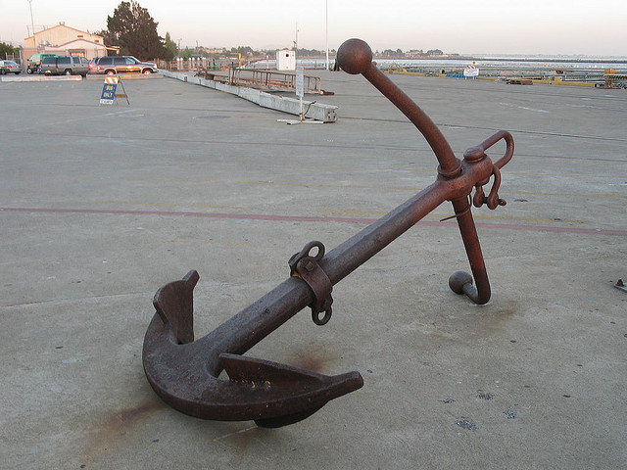

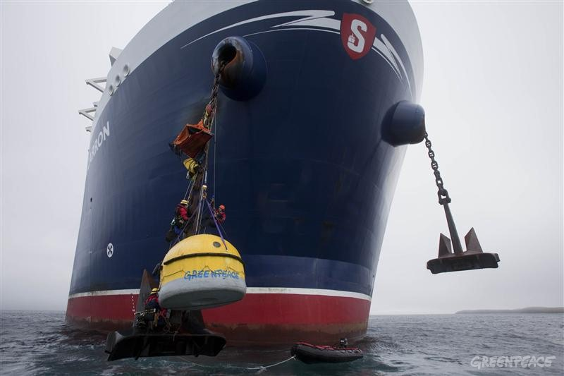

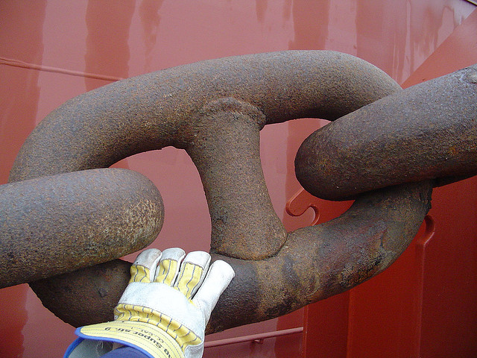

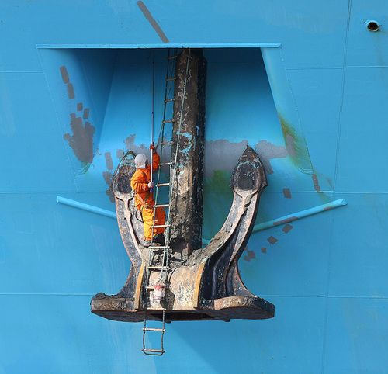

[Type a quote from the document or the summary of an interesting point. You can position the text box anywhere in the document. Use the Drawing Tools tab to change the formatting of the pull quote text box.]
[Type a quote from the document or the summary of an interesting point. You can position the text box anywhere in the document. Use the Drawing Tools tab to change the formatting of the pull quote text box.]
[Type a quote from the document or the summary of an interesting point. You can position the text box anywhere in the document. Use the Drawing Tools tab to change the formatting of the pull quote text box.]

