Ecclesiastes 9
“Work Hard, Play Hard, Pray Hard”

Scripture: Ecclesiastes 9:1-12

Memory Verse: Colossians 3:23 “And whatever you do, do it heartily, as to the Lord and not to men.”

Lesson Focus: This section of Scripture provides us with great practical wisdom for approaching something we all have to do: work. See the diagram on the last page which will be central to our lesson showing how work, play, and prayer all fit together

Activities and Crafts: Coloring Picture of Work Hard. Word Search of different terms from lesson, Bring It Home Discussion for 3rd – 5th.
Craft for 1st & 2nd: Paper Chain

Introduction:

Ecclesiastes is a book that challenges us to THINK. (Matthew 22:37, Romans 12:2)

To get kids brains in “think” mode, we will introduce each lesson of Ecclesiastes with some sort of brain teaser. For this week, below are several pictures communicating an idea. Draw them on the board and see if they can figure out each one (answers provided).

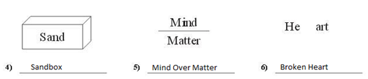

Starter Activity: What do you want to be or do when you grow up? Ask the kids this question and then ask them why that is what they want to be.

Many times throughout Ecclesiastes Solomon has emphasized that it is good to work and play and see both as a gift from God. As a review, read Eccl. 2:24, Eccl. 3:12-13, Eccl. 5:18, and/or Eccl. 8:15.

Q: Who is at the center of all of these verses? God! We are to welcome Him into our answer to the question of what I want to be/do when I grow up.

Today we will go a little bit deeper into the idea of doing our work for the glory of God, just as our memory verse says.

Bible Study:

Last week we wrestled with the idea of God’s authority and having a “Your Wish Is My Command” attitude toward Him. We will actually start our study in v. 16 of chapter 8 to get the context for the start of chapter 9.

Eccl 8:16-9:1: Remember our lesson from last week we discussed how Solomon was asking “Why” things happen, sometimes good sometimes bad. God doesn’t always tell us and we simply must trust Him or reject Him.

Notice in v. 1 of chapter 9 that Solomon expresses the idea of being “in the hand of God”. It’s like the old song says, “He’s Got the Whole World in His Hands”.

If you trust in God, this should provide tremendous comfort. For think about the hands of Jesus, that were pierced for your sin….that will never let you go!
If you don’t trust in God, this should make you uneasy for Hebrews 10:31 says that it is a “terrifying thing to fall into the hands of the living God.” It is verses like this that remind us to fear God and be in awe of God for His greatness, holiness, and lovingkindness.

Eccl 9:2-3: All die *, whether you trust in God or not! This is the harsh reality of the world we live in. Notice in v. 3 Solomon really gets to the root of our problem, sin. Remember God created the world originally good, but we brought sin into the world and now it is broken. Solomon says there is so much sin, that it is madness out there.

Q: How many of you guys watch or read the news with your parents/guardians? What do you see? Madness!
- Police officers getting shot
- War after war
- Etc, etc, etc

Teachers: Consider checking the news this week for an age-appropriate news story to share to draw this point out further.

Solomon wrote this 3000 years ago and nothing has changed. The world is still broken because of our sin.

Eccl 9:4-6: Even though we will die, we still have hope while we still live. So what are we to do? We can either be overcome by this world, the madness of sin, and the sobering fact that we will die OR we can look to Jesus, Who holds us in His hands and with Him overcome the world! Read John 16:33.

Throughout this book, Solomon has been very, very close to giving up and being overcome by the world. He looks at the madness/evil in the world, the sinfulness of man, the reality that we will die, and is tempted to just throw in the towel. But once again he will bring God back into the picture. The heart of our study today is Solomon’s response to the harshness of life “under the sun” which we will summarize with three points:
- Work Hard
- Play Hard
- Pray Hard

Teachers: See the diagram on the last page of the lesson. Please consider drawing this on the white board showing how these three points fit together. I plan to progressively draw each circle as I walk through the rest of the lesson (i.e. first Work Hard, second Play Hard, and finally Pray Hard) to illustrate how they all relate to each other.

Eccl 9:7-10: So does Solomon give up? No! In these verses, Solomon brings God back into the picture and encourages us to work hard, play hard, and pray hard.

Work Hard (draw this circle first)
Notice v. 10 says “whatever your hand finds to do, do it with all of your might!”

Remember at the beginning of our lesson, I asked you all what you wanted to do and/or be when you grow up. It will take “hard work” to get there, but Solomon would encourage you to work hard, with God’s blessing.

Read Proverbs 13:4 and/or Proverbs 21:25-26. Beware of laziness and idleness!
- Note: Getting rich isn’t the goal. But God is pleased with good, diligent work.

Teachers: When you get to this section, consider sharing with the kids some personal examples of yours where you have worked hard to complete or attain something.

Remember that work is good and a gift from God. Therefore, we should not see work as some evil thing that we are to avoid.

Q: What work do all of you have before you? School, chores, etc.!
- Teachers: Consider writing in the answers within the circle

Play Hard (draw this circle next with an intersection of joy as shown)
Notice v. 7 and v. 9 both express the idea of living joyfully.

Life isn’t all about work. There are times to play and enjoy the fruits of your work as well.

Read Psalm 128:2: Work hard so that you can play hard!

Teachers: Again, consider sharing with the kids some personal activities you like to do that bring you joy.

Q: What are some things that you all like to do for fun?
- Teachers: Consider filling in the answers into the circle

When you guys are at school, you usually have a time of recess. Similarly, in life there are times when you take a break, and enjoy what God has given you.

Notice the intersection of work and play (JOY!). How blessed is the one who finds so much satisfaction in his/her work that it is considered play! *

Pray Hard (finally, draw this circle around it all and put Jesus at the top!)

This is the most important part. We are to “pray hard” so that we keep God central to ALL (work and play) that we do!

Teachers: One last time, share some personal examples of how you welcome Jesus into your work and your play.

Q: What happens if we do not “pray hard”?
A: We fall into the “under the sun” trap that Solomon has warned us about all throughout this book. Remember (Eccl. 2:1-11) Solomon tried to find satisfaction in work and play by themselves (apart from God) and said it was all meaningless! We must not get so consumed with our work or play that we forget God! Remember God has put eternity in our hearts (Eccl. 3:11).

Eccl 9:11-12: Furthermore, sometimes things don’t go our way.

We might work the hardest, but still not succeed!
We might play the hardest (say training for a race), but still not win!
If God is not #1, we will give up and despair!

Key Point: But if we welcome God in, trust in Him, and do all that we do for Him, not only will we have great joy, but we will be able to endure those difficult times when things don’t seem to go as we expect.

Q: Who knows who Tim Tebow is and his story?
A: He broke records in college, won the Heisman Trophy, was drafted in the first round by the Broncos and even advanced them into the playoffs his rookie year. But even more importantly, he is a firm believer in Jesus Christ and became famous for being outspoken for his love of Jesus. He even put John 3:16 on his eye black and according to Wikipedia generated over 90 million searches in 24 hours!

Wouldn’t you expect God to reward him with a brilliant NFL career? Didn’t happen! How did he respond? He has been able to endure the storms (he wrote a book called “Shaken” chronicling his experience) as he continues to keep Jesus Christ central to ALL he does!

Bring It Home

Scripture from Lesson: Ecclesiastes 9:1-12
Lesson Theme: Work Hard, Play Hard, Pray Hard

Memory Verse: Colossians 3:23 “And whatever you do, do it heartily, as to the Lord and not to men.”

Teachers/Parents: We drew out the below diagram during class to characterize the work ethic discussed from Ecclesiastes 9, also considering the whole word of God.
- What are some every day activities in your life that you would fill in the “Work Hard” and “Play Hard” circles?
- Can you share some experiences where there was an intersection between work and play that brought great joy?
- Why do you think the work and play circles are inside of the pray circle?

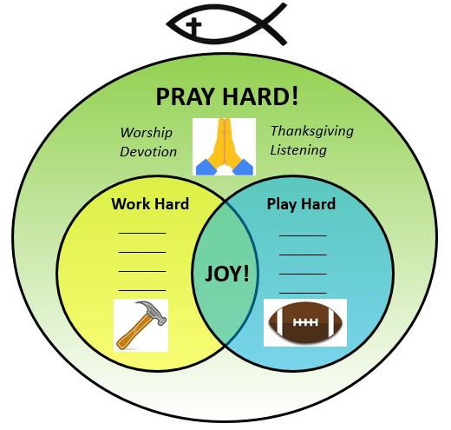

Further Discussion Questions:

- Sometimes we think that work is evil and to be avoided. But read Genesis 2:15. Here is Adam in paradise before sin and the fall. What did God have him do?

- What are the dangers of living in only the “Work Hard” circle? Hint: Read Luke 10:38-42.

- What are the dangers of living in only the “Play Hard” circle? Hint: Read Luke 15:11-16. Read Proverbs 31:10-31 for an example of someone who has the proper balance and also welcomes the Lord into it all.

- We asked the kids what they want to be when they grow up and challenged them to welcome Jesus into the answer to that question. Sometimes our identity is overly wrapped up in our work or play. What steps can we take to ensure that in whatever we do, our identity is first and foremost in Jesus Christ?

