Breakfast Menu offered Tuesday – Friday from 7:00am – 10:30am

Weekday Lunch Menu offered Tuesday – Friday from 10:30am - 1:00pm
Service Time Dinner Menu Offered on Wednesday and Saturday Nights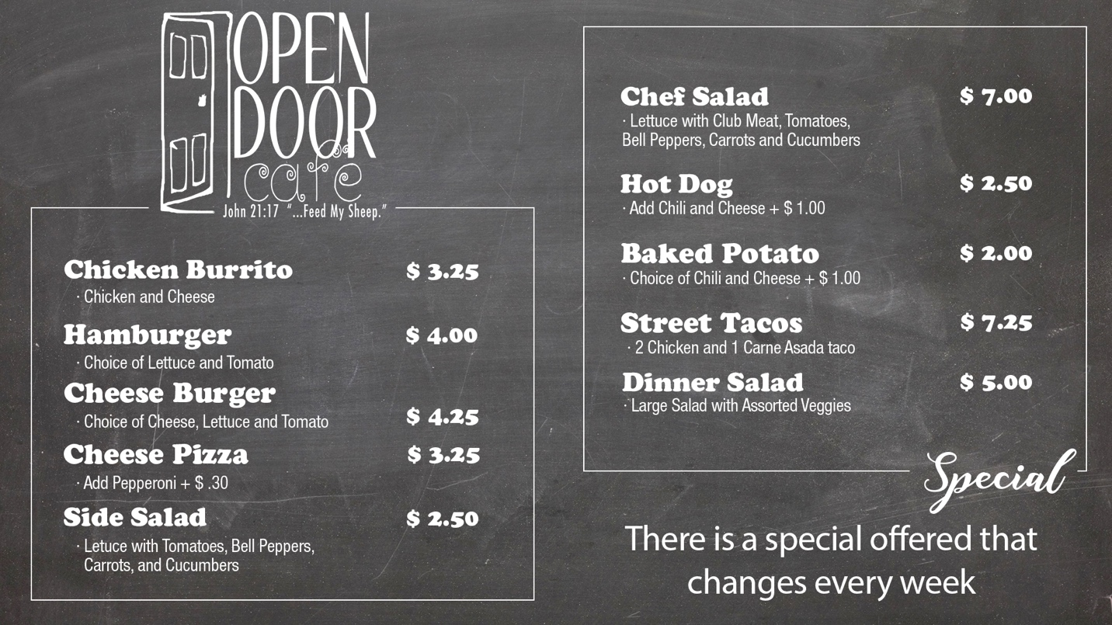

Sunday Breakfast Menu offered each Sunday Morning
